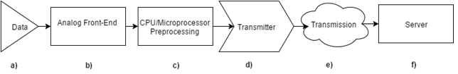

Figure 1. System Block Diagrams which shows each component of the complete system

Figure 2. nRF52 memory map.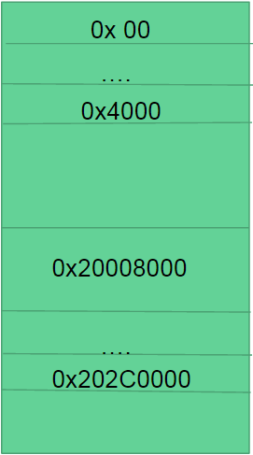

ROM: 0x0 - 0x4000, RAM: 0x20008000 - 0x202C0000

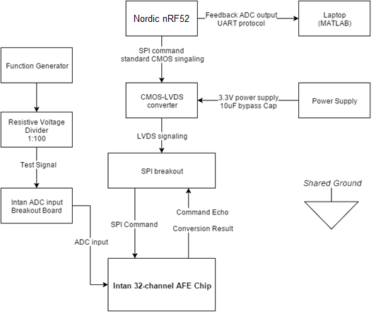

Figure 3. Complete System Setup for configuration and testing of Intan RHD2132 Analog-Front-End Chip